Engineering Design & Development (EDD)

Syllabus & Course Expectations
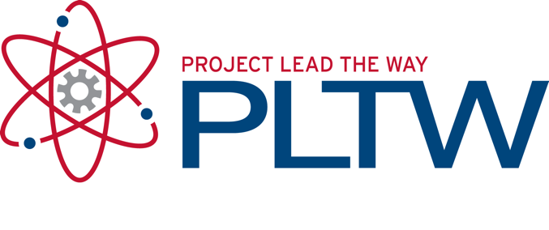
2019-2020
Ms. Breanna Snyder, i223
Email: bsnyder@smmusd.org
Website: www.breannasnyder.com & www.pltw.org
Google Classroom Code: i3p9ihs
Phone: 310-395-3204 ext. 71223

COURSE DESCRIPTION

Engineering Design and Development (EDD) is the capstone course in the PLTW high school engineering program. It is an engineering research course in which students work in teams to research, design and develop an original solution to a valid open-ended technical problem by applying the engineering design process. At the end of the course, student teams must submit a final written report as well as report and defend their final solution to outside reviewer panel (trade show). In addition, students will complete smaller projects during first semester.

RECOMMENDED MATERIALS

Students enrolled in PLTW EDD are not required to pay any fee, deposit, or other charge for participation in an educational activity offered by the school or the Santa Monica-Malibu Unified School District, except as authorized by law. Donations are sought and accepted for various activities and supplies, and are at times critical to the continued success of classes and activities, but donations are voluntary.

Listed below are recommended materials for students taking PLTW EDD. These materials are not required, and full participation in the course does not require the purchase of any of these materials. State law requires us to provide a public education free of charge. Subject to certain exceptions, the right to a free public education means we cannot require students or their families to purchase materials, supplies, equipment or uniforms for any school activity, to pay security deposits for access, participation, materials, or equipment, or to make donations to a class activity or program.

Recommended Materials:
- Pens and pencils
- Folder with paper
- *Instead of an engineering notebook students will create a digital portfolio

DONATION REQUEST
State law requires us to provide a public education free of charge. Subject to certain exceptions, the right to a free public education means we cannot require students or their families to purchase supplies. Santa Monica High School will provide all necessary supplies for your child to have a quality educational experience.

Due to limited funding for necessary materials/supplies we ask that parents/guardians make a donation to the PLTW Engineering Class to purchase materials for the Year Long Project, the JPL competition materials, and for class field trips. We are requesting a donation of $100 per student, but any amount is greatly appreciated. These funds will make the 4th year engineering class better for all our students. You may send this donation by check made out to Santa Monica High School ASB and write “ PLTW” in the memo.

I thank you in advance for your willingness to help support the program.

GRADING
Grades will be broken down into four grading categories:
25% Individual Projects
25% Group Projects
20 % Presentations
25% Assignments/Homework (Personal Website and Blog)
5% Clean-Up

LAB CODE OF CONDUCT
When participating in a lab students are expected to take care of and properly use all equipment. If you accidentally break an item or are unsure of the proper use of equipment, notify the teacher immediately. Goofing around or failure to follow instructions may result in disciplinary action, and possibly exclusion from lab /activity participation.
- No food, no drinks.
- Do not touch projects that are not yours.
- Do not operate power tools without teacher approval.
- Clear all table tops and floors before you leave.
- Log off your computer before you leave and store into the correct computer slot.
*Always be mindful of your time and begin cleaning up your area at least 5 minutes before class ends.

ABSENCES & TARDIES
If you are absent, it is your responsibility to get caught up with notes, assignment and/or projects. First check class website, then ask a peer, and if you still have questions come ask me outside of class time. Excessive absences may result in no credit for the course. Students are expected to be in their seat ready to learn when the bell rings.

CONCEPT CATEGORIES
Students will be assessed for the following EDD Concepts listed below.
SEMESTER 1 | SEMESTER 2
- Personal Website/Blog  - What’s the Problem?  - Individual Research and Presentation of an innovative solution.  - JPL Challenge & Field Trip  - Capstone Project  - Research a Problem  - Design a Solution | - Capstone Project  - Create a Prototype & Testing Plan  - Evaluate & Reflect on the Design Process  - Present the Design Process  - Beyond EDD  - Ethics In Engineering  - Patent Research

TECHNOLOGY
Playing non-approved games, downloading files or music, participating in online gaming or social networking, and streaming video are not permitted in class. Use of SMMUSD equipment is a privilege, not a right. Those who choose to violate any District Policy will result in loss of technology privileges and/or disciplinary action.
- Computer – allowed during class hours, at the discretion of Mrs. Snyder
- iPods/Music devices – not allowed during class hours
- Phones – not allowed during class hours

PLAGIARISM & CHEATING Copying of any work or providing work for another student to copy is not permitted in any circumstances. Any student involved in cheating will receive an automatic 0 for their grade and will be referred for disciplinary action.

*Please keep the syllabus for your records and return THIS PAGE ONLY to Ms. Snyder

Santa Monica High School

PLTW EDD

2019-2020
Syllabus Contract
Student Name: _____________________________ ___________________________ Class Period: ______
Last First
I have read and understand the 2019-2020 Course Syllabus | ____________ (Initial)
I agree to abide by the SAMOHI Academic Honesty Policy | ____________ (Initial
I have read and agree to the Lab Code of Conduct. | ____________ (Initial
I understand that it is my responsibility to find out the work I’ve missed and turn it in no later than ONE day after I return from an absence. | ____________ (Initial
I agree to have my cell phone turned off and put away during the class period. I understand that if I have my cell phone out then I will have it taken away and I will have to pick it up from my house office. | ____________ (Initial
I agree to participate safely and enthusiastically in all activities. | ____________ (Initial

Student Signature Date

Parent Signature Date

By signing this paper, you verify that you have read, understood, and agreed to the policies set forth on the Digital Electronics Syllabus. This includes your understanding of the expectations for students, classroom policies, and grading. You understand that you must follow all safety rules, class rules and policies.

