Capstone Project: WAXOFF

Element A

Problem Statement:
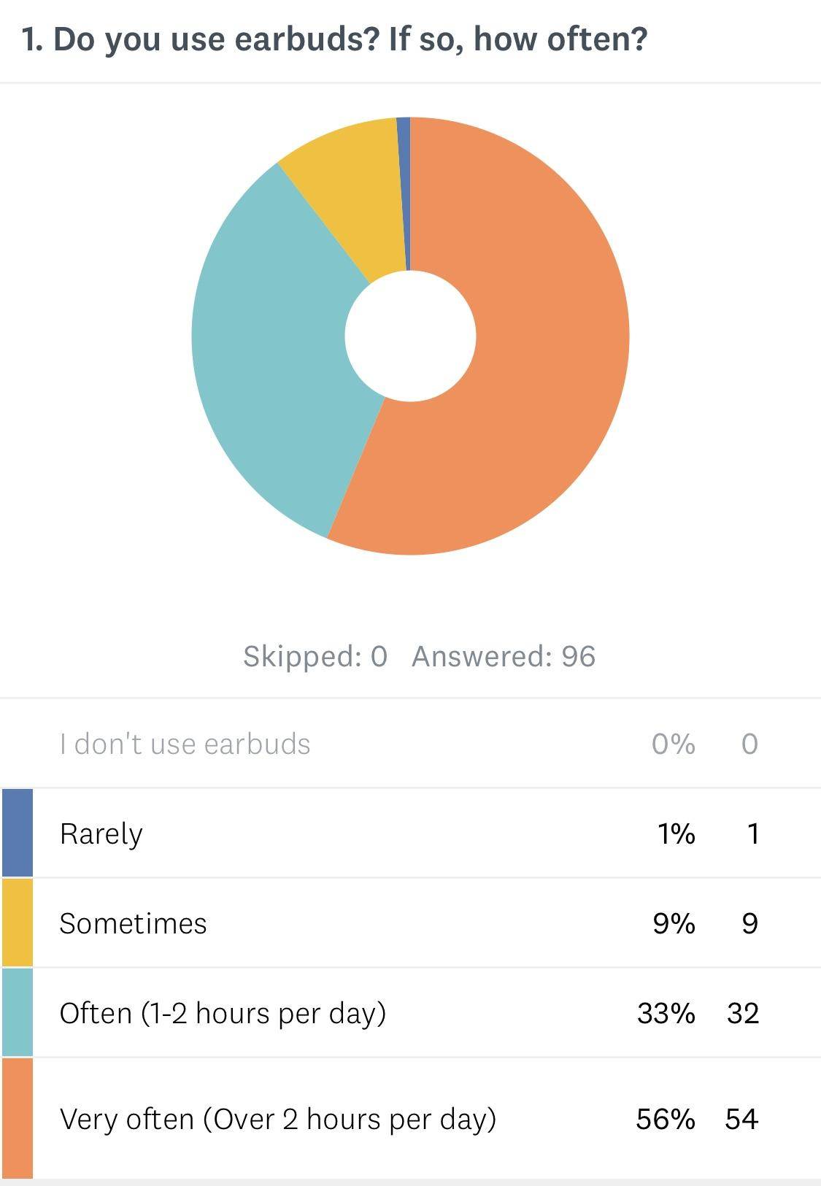
Overuse of unsanitary earbuds can cause dirt/wax build-up in the ear canal, which may lead to ear infection. Consistently using unsanitary earbuds can lead to infection and disease, such as middle ear infections, fungus, or swimmer’s ear. Hundreds of millions of people use earbuds every day which is why there should be more attention given to the issue.

Problem Background/Statistics:
Earbuds sit in the area of the canal where wax is produced. By blocking the wax’s natural path of exit, earbuds collect unsanitary wax, which can result in countless ear issues. The Malaysian Journal of Medical Sciences found that about 10% of earbud users developed ear diseases and 22% experienced hearing impairment over a 2-3 year period due to unsanitary earbuds. Allina Health also states that “Earbuds can increase ear wax build-up. Even though our ears are self-cleaning, if we block the canal for multiple hours a day, the wax will not be able to work itself out of the ear.”

Validation of Problem:
According to Whittier Hospital Medical Center, “Nowadays, it’s almost impossible to find a person who doesn’t own a pair of earbuds… The moment you put them in, your earbuds can introduce dirt and bacteria into your ear.”⁽¹⁾ On top of this, the New York Post states that “...a 31-year-old man was left battling a deadly brain infection from using cotton buds (Q-tips) in his ears. Infections can also be reintroduced by soiled earphones...” They go on to say that, “Symptoms can include pain, odor, discharge and itching.” This is even more of a reason to pursue a solution to this problem as it proves just how harmful infections can be. We created a survey to gather more information on the issue. These were the questions on it:
- Do you use earbuds? If so, how often?
- Do you ever share your earbuds?
- How dirty are your earbuds? (1=Clean, 10=Extremely Dirty)
- Do you clean your earbuds?
- If so, how do you clean your earbuds?
- How often do you clean your earbuds?
- Would you clean your earbuds more often if it was easy to do?
- Are you aware of health issues caused by unsanitary earbuds?
There are still no marketed products to effectively and safely clean one’s earbuds. However, there are many common household solutions to cleaning them. Some habitual cleaning methods include using a cotton-swab, rubbing alcohol, or a toothpick to pick out the wax.

Element B
Although these household methods are slightly effective, after our research with Dr. Blanca Andres, M.D., we realized that each of these solutions managed to have their own great cons. Starting with the cotton-swab, we quickly realized that although the cotton-swab removes all the wax, it has no way of disinfecting the earbud. On the other hand, the rubbing alcohol disinfects the earbud, but has no way to properly remove the wax. Lastly, despite the fact that the toothpick is the most efficient method, it doesn’t properly remove all the wax, and also has no way of disinfecting the earbud. On top of this, all household items, such as these, that aren’t stored properly can carry their own bacteria which can increase the chance of infection.

Current Products/Patents
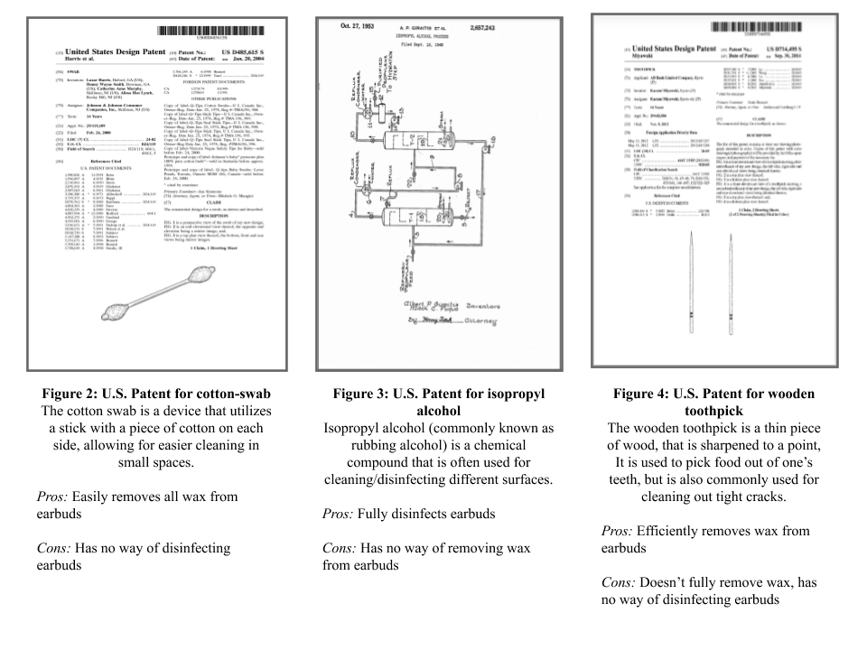

Element C
There are many things that our group feels an earbud cleaning device should be. We spent a lot of time brainstorming as well as collecting ideas from our peers. Based on data collected from our research survey, 67% of participants admitted to sharing earbuds. Of that 67%, only 7% of participants cleaned their earbuds with a method that disinfects. For that reason we decided disinfecting was the utmost priority in our design, as it solves an actual health issue that is not acknowledged enough. Dr. Andres validated this priority by discussing with us the possible health risks that could come from bacterial growth. Secondly, we decided that removing excess wax was the second most important requirement, seeing as wax left behind would promote bacterial growth. In the end we decided that our device would have to:

Design Criteria
- Disinfect
- Remove wax
- Work quickly - so user’s will use it more frequently
- Be easy to use
- Have charging capabilities - so user’s will use it more frequently
- Be aesthetically pleasing
Our primary stakeholders include all people who use earbuds. This is a very broad customer base. In order to get input from our target audience about the need and functionality of our device, we conducted a market research survey about the necessity and use of our product.

Element D
To begin our design we made a prioritized list of requirements we had for our design, we listed them in order from most important to least important.

Prioritized list of all design goals and requirements:
  - Disinfects at least 99% of all bacteria and microorganisms
  - Completely removes all visible wax from earbuds.
  - Takes 30 mins. or less to fully disinfect (99%) the earbuds.
  - Can be activated in one step.
  - Additionally includes a wireless charging pad to charge earbuds while they are being cleaned.
  - Includes a charging dock for other earbuds which need to be plugged in.
  - Aesthetically pleasing
  - Appeals to a younger audience

After making our prioritized list of design requirements we created a decision matrix which would allow us to weigh a requirement based on its importance. Then we could better compare our different designs, and take away the quantitative score of which design was best.

Peer Feedback
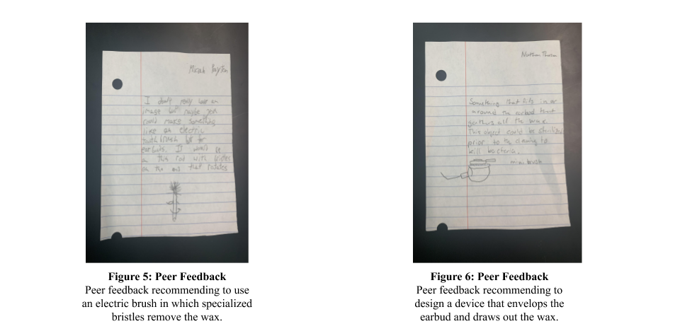

Initial Design Sketches
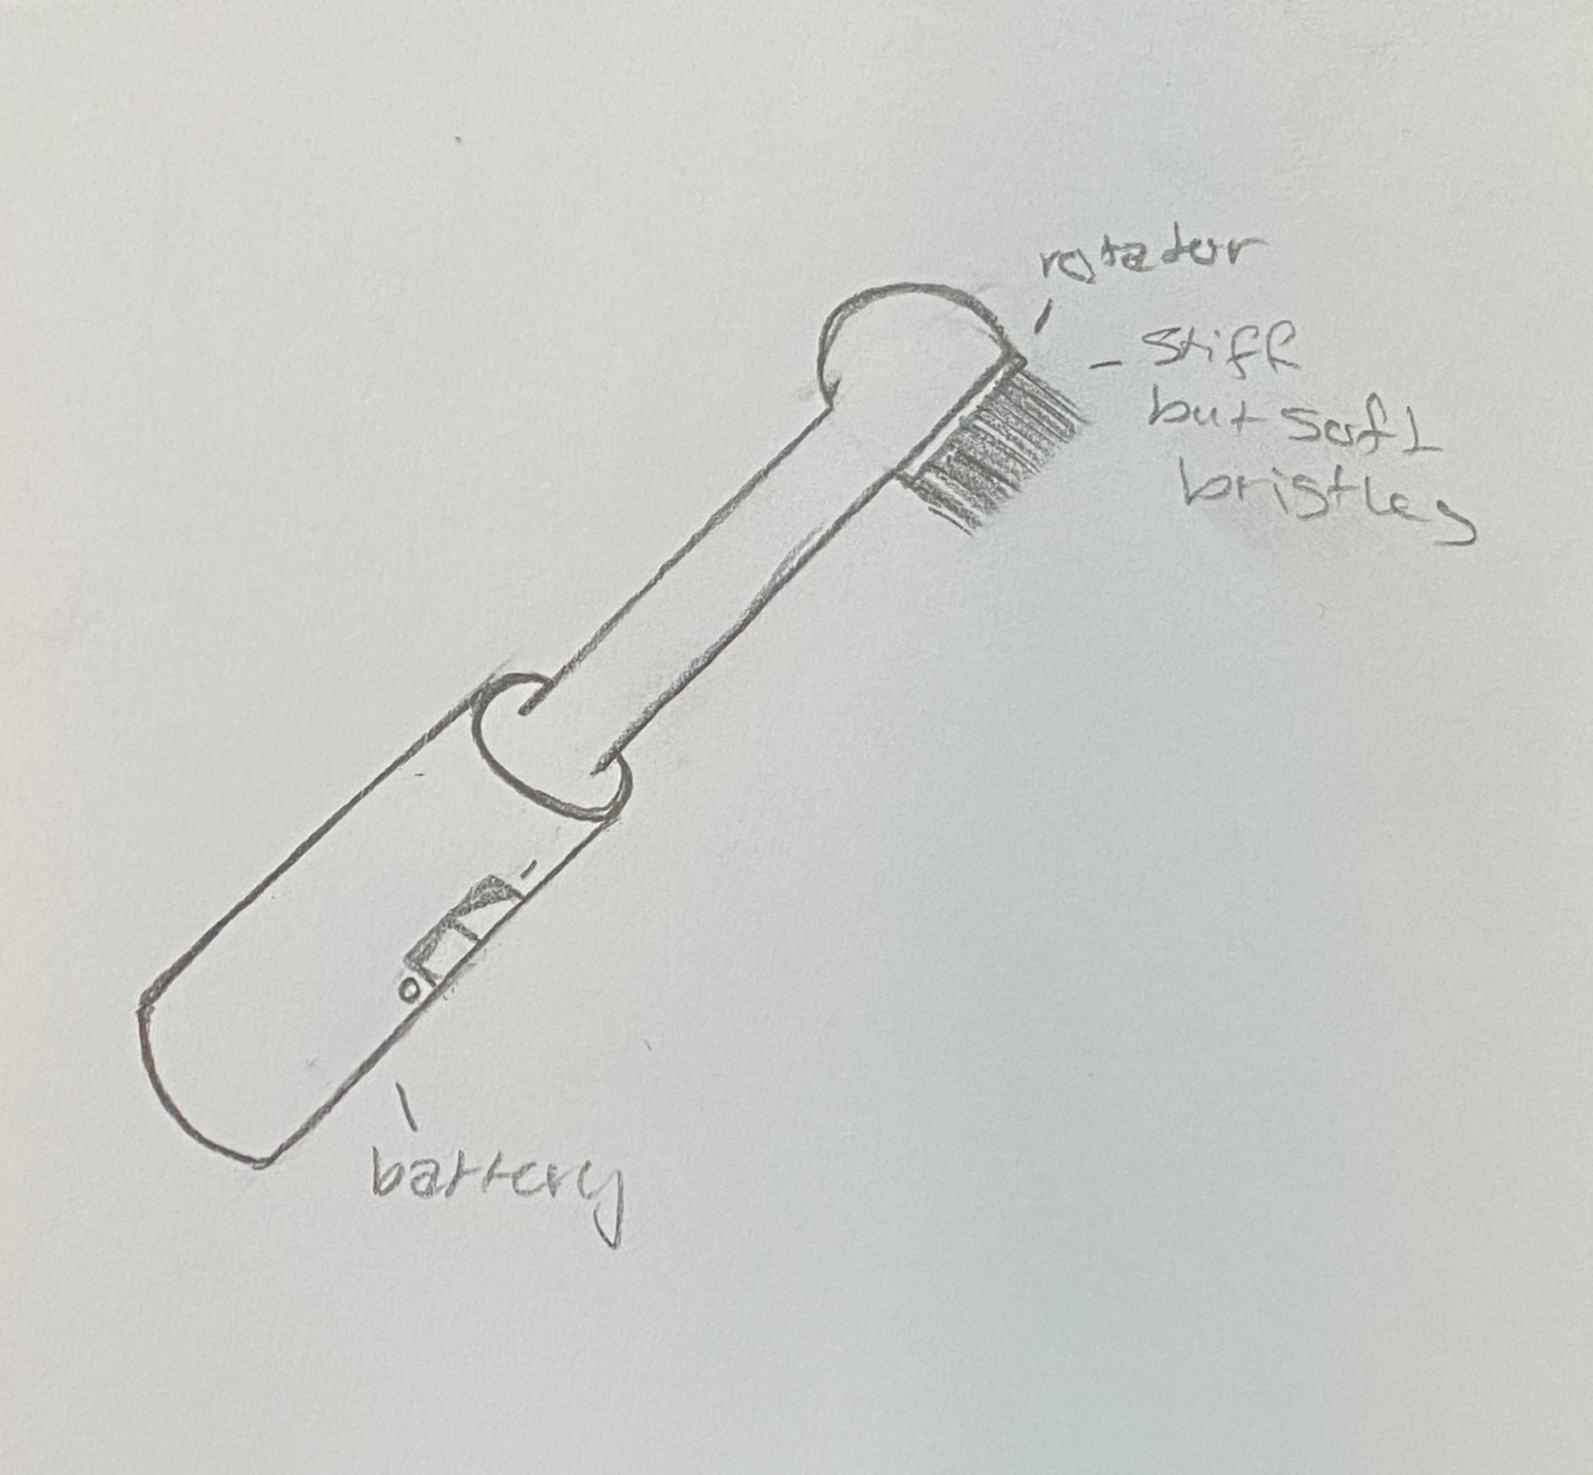
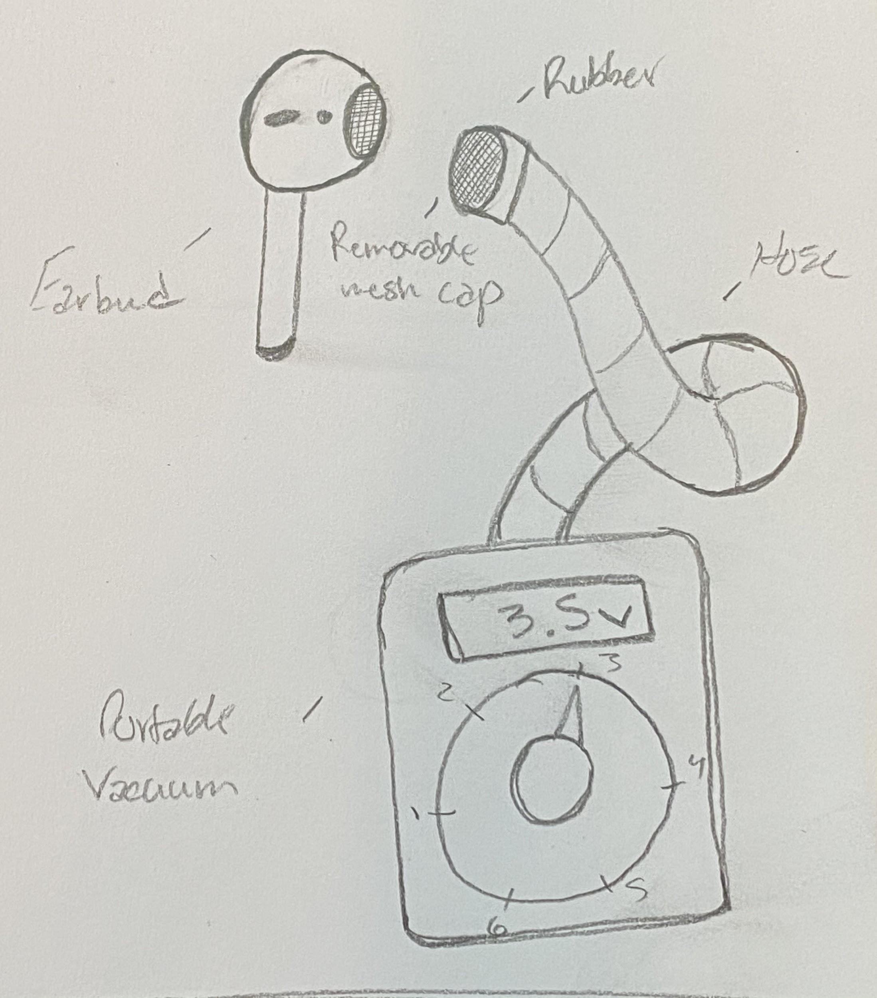
Figure 7: Vibrating Brush Sketch Figure 8: “Mini-Vacuum” Sketch
These initial ideas/designs were based off of peer feedback we received during the surveying phase of our research.

Decision Matrix
Criteria | Weighting | UV-C Box |  | Mini Vacuum |  | Vibrating Brush
 |  | RATING | W/ WEIGHT | RATING | W/ WEIGHT | RATING | W/ WEIGHT
Disinfection | 3 | 8 | 24 | 1 | 3 | 1 | 3
Wax Removal | 3 | 1 | 3 | 7 | 21 | 8 | 24
Time/Efficiency | 2.5 | 4 | 10 | 9 | 22.5 | 7 | 17.5
Ease of Use | 2.5 | 9 | 22.5 | 5 | 12.5 | 3 | 7.5
Charging Capability | 1.5 | 10 | 15 | 1 | 1.5 | 1 | 1.5
Aesthetics | 1 | 10 | 10 | 4 | 4 | 6 | 6
TOTAL: |  | 84.5 |  | 64.5 |  | 59.5
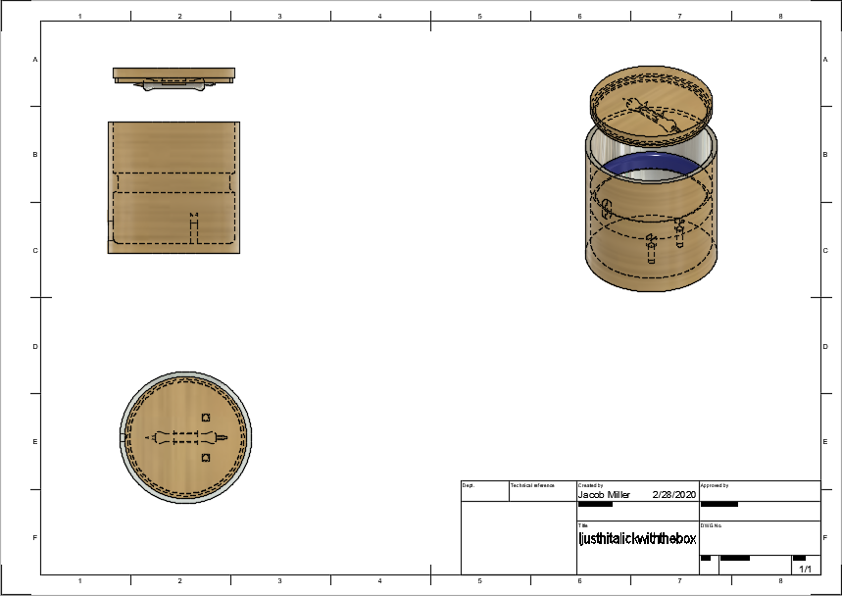
From this we determined that the UV-C box was by far the best design as it is the only solution that disinfects, however it does not remove physical wax at all. Because the box is easier to modify we decided to take certain elements from the other two designs to improve the UV-C box’s capabilities in its weakest areas such as physical wax removal and time it takes to complete disinfecting. One element we have decided to add is a brush/pick which would be able to remove physical wax, and thus reduce the time it takes to disinfect, since there would be less wax present.

Final Design Inventor File
Figure 9: UV-C Box Initial Inventor File

As seen in the file above, the box became more of a cylinder. We chose this shape because it will better distribute the UV-C light, making it more effective at disinfecting. The box is wide enough for a wireless charging case to be placed comfortably inside. The bottom of the box also has a hole in it for a cable to run through, allowing users to insert their own cable to charge their cases (different wireless earbuds use different cables). There are also two slots for the earbuds themselves to be placed, the waxy mesh would be faced directly towards the UV-C light, which is best for disinfection. The bottom of the box is flat so a wireless charging pad can be added later if desired. Finally, the brush/pick tool fits the lid of the box. When a user is ready to remove wax from their earbuds all they have to do is detach it from the lid and pick away. Also, the tool is within the box so it should also be disinfected while the box is closed.

Element E
In order to support the design elements of our device we need to further research the following:

Science and Engineering Concepts that relates to the disinfection design criteria
- Reflectance
  - How light/radiation reflects off of a surface.

- Irradiation
  - The emission of energy as electromagnetic waves or as moving subatomic particles, especially high-energy particles which cause ionization.
- Wavelength Frequencies
  - Frequency (Hertz) equals the number of waves that passes a given point per second.

We need to test how UV-C light reflects off different materials and shapes, while also researching how different UV-C frequencies reflect and disinfect differently. On top of this, we need to look into what requirements are needed to make UV-C irradiation possible, while also investigating how to maximize the efficiency of the irradiation process. By better understanding these three concepts we hope to maximize the disinfecting capabilities of our UV-C box. The reflectance directly affects the type of material we will use inside our box, and what shape we use as well. Understanding the irradiation of UV-C will allow us to increase the efficiency of its disinfection. Although we have already done research on wavelength, and concluded that UV-C will be the best for disinfecting earbuds, we can still do more research and possibly find more. Our mentor, Dr. Blanca Andres, can help us with this. Being in the medical field, she can help teach us about sterilization and how to make our product as effective as possible. We believe our design should be optimal in practice throughout the design stage. However, we do need to test this by comparing the light distribution of a cylindrical box to a rectangular box. Once we have improved our current design based on our own observations, we will hopefully produce enough prototypes to receive input on our design from a select group of testers. Lastly, to test if the UV-C box can successfully complete disinfection, we will cultivate the bacteria on the earbuds before and after cleaning with our device (using petri dishes). If the device can successfully disinfect a minimum of 99% of the bacteria, there should be no growth present.

Element F

Competitors:
- UV iPhone Disinfection - $40-80
- Wax Wacker- Free (Pay for shipping)

We believe consumers will pay very little. Since there are household solutions to this problem the average consumer is most likely not willing to pay very much. Every UV sanitizer has very few reviews on Amazon, leading us to believe that there are little purchases actually made. However, if our product is cheap enough, and we can inform people of the importance of disinfecting their earbuds (Corona hysteria helps) then there may actually be a large market. Our product, unlike most products on the market, charges the earbuds if they are wireless. Furthermore, we combined both types of cleaners on the market already by disinfecting and including a tool for gunk removal.

There are several reasons that a demand exists for our product. Firstly, there is a severe lack of products that exist that are intended for this purpose. If we can bring awareness to the issue we are trying to solve through advertisements, it should be fairly easy to garner a customer base. Another reason that there is a demand for our product is the current health crisis surrounding the Coronavirus. Currently the public is in a state of panic and most people have been doing everything possible to make sure that they stay healthy. Sharing earbuds is a very easy way to spread germs and sanitization of earbuds could potentially become part of people strategies that could be used to lower the chances of infection. On top of all of this, our market research survey of our potential customers shows that there is an interest in our device. 86% of people said they would clean their earbuds more if it was easier to do so. Once we begin manufacturing our product, we think our main target audience will be younger people since they are more likely to use earbuds frequently. We will also target germaphobes and older people who use hearing aids since those could be cleaned as well. We think these people will buy our product because they either want to take their health more seriously or already clean their earbuds and want a more convenient and effective alternative.

To manufacture the device, we plan on assembling the device’s different components completely ourselves. We will be 3-D printing the casing for each device, and then will install the different components by hand (such as the mirrors and the wireless charger). We will also be wiring the device by hand. To distribute them, we currently plan on shipping through USPS, using the top loading medium flat rate box (which would cost a flat rate of $11.80 for each shipment). However, we are looking into a cheaper shipping alternative.

Element G

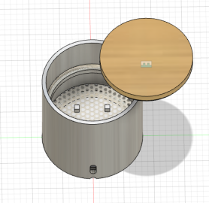
Testable Parameters (If built):
- Disinfecting capabilities (how effective is the device at disinfecting earbuds).
- Charging capabilities (how effective is the device at charging earbuds).
- Light leakage (how well does the device seal the UV light while in use).
- Disinfecting efficiency (how fast is the device at disinfecting earbuds).

Figure 10: Final UV-C Box design

Cost (excluding shipping):
- Flexible Mirror Sheets - $10.00/3 sheets
- Bamboo Containers - $10.00
- UVC Germicidal Light Strips - $4.00/30 LEDs
- Wall AC Adaptor - $3.00 (requires minimum order of 10 units)
- Wireless Charger Dock - $5.50 (requires minimum order of 50 units)
- $8.90 (for individual device, different brand)
- Cleaning Tool - $3.00
- Mesh - $2.00/2 yards x 44 inches
- Total (Average cost per unit): $30.50

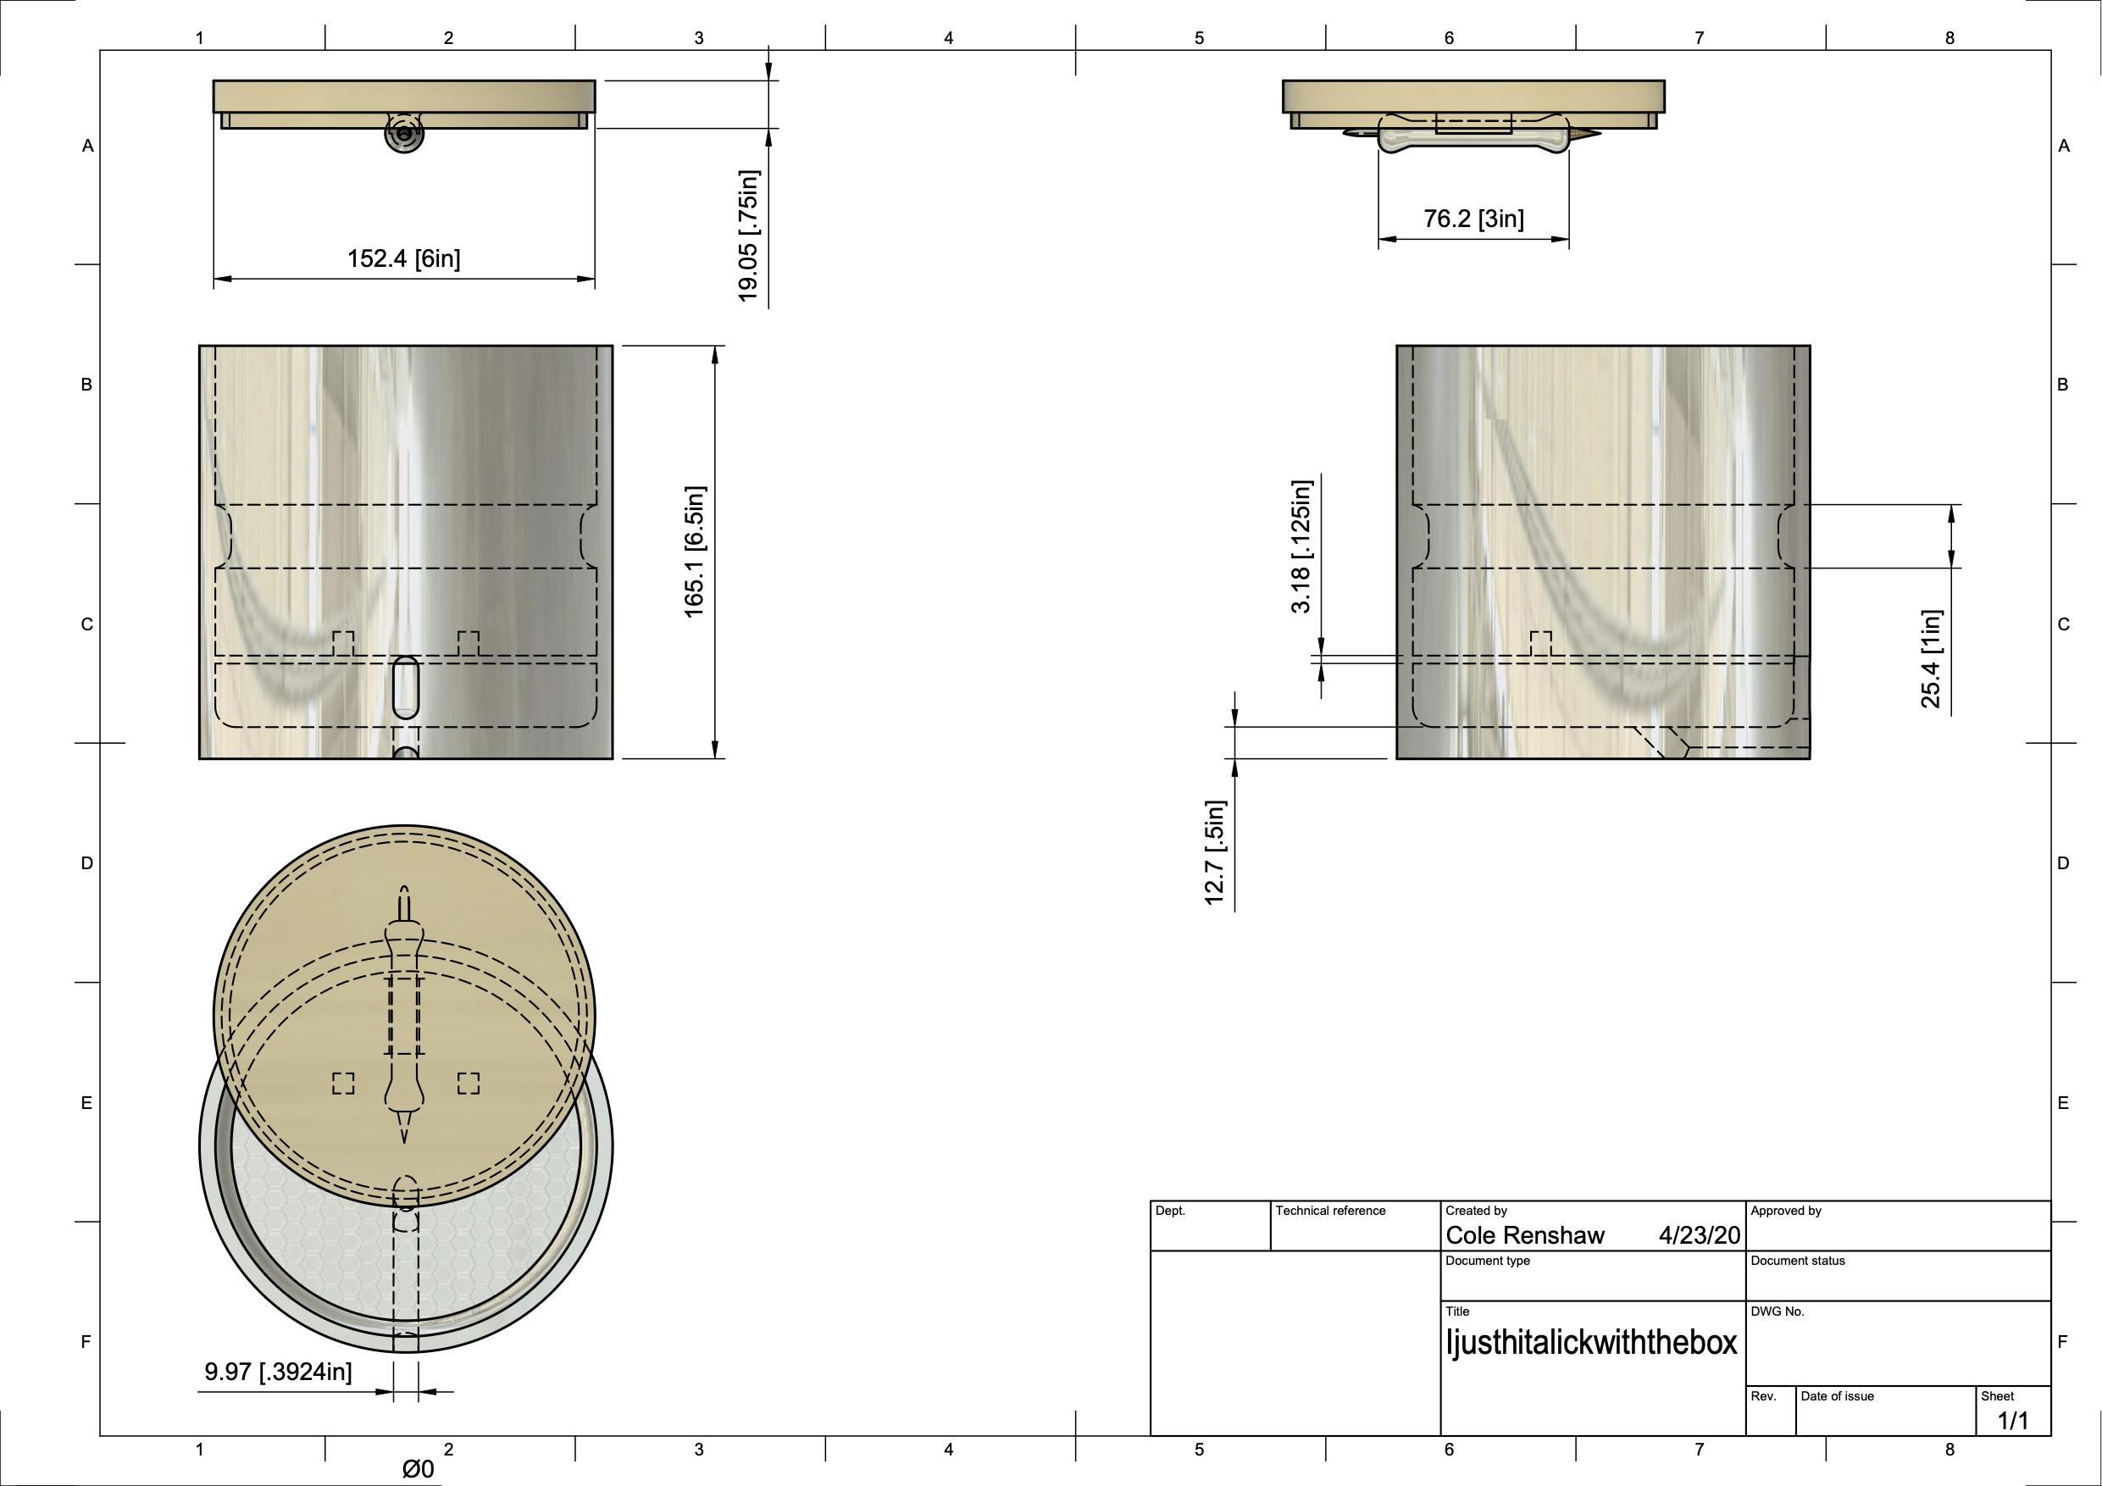

Figure 11: UV-C Box Final Inventor Section View File

Element H

Testing procedures and criteria:
- Disinfecting capabilities
  - We will determine how effective our device is at disinfecting earbuds by growing three cultures: one swab from an unused earbud (control), one swab from a used earbud before entering our device, and one swab from a used earbud after being cleaned by our device.
- Charging capabilities
  - We will determine how effective our device is at charging earbuds by timing how long it takes to fully charge a pair of wireless earbuds and comparing our time to traditional charging methods such as using a cable or external wireless charging pad.
- Light leakage
  - We will determine how well our device contains the light emitted by the UV strips inside of it by having it run while in a completely dark room as we check it.
- Disinfecting efficiency
  - If our device does in fact disinfect, we also need to test at what rate it disinfects. We will determine this by calculating the percent reduction of bacteria on used earbuds after being cleansed in our device for varying lengths of time.

Describe who can help you validate your STEM work:
- We will need experts in mechanical engineering and medicine to help validate our STEM work. We will need the mechanical engineer to help verify our assembly and design, and someone specializing in medicine to verify our bacterial culture test.
- Get written feedback from your mentor about your inventor file and progress so far.

Describe additional science concepts you need to investigate now that you are limited to digital resources:
- Rectifying -
  - Converting alternating current into direct current

Electricity provided in one’s home is in the form of alternating current. Alternating current does not provide a steady form of power, and instead acts as a pulsating power. Our devices components (similar to other electronic devices), require a steady, constant form of power. So, to do this, the device must rectify the alternating current (AC) into a direct current (DC).

Element I
Analysis of Results:
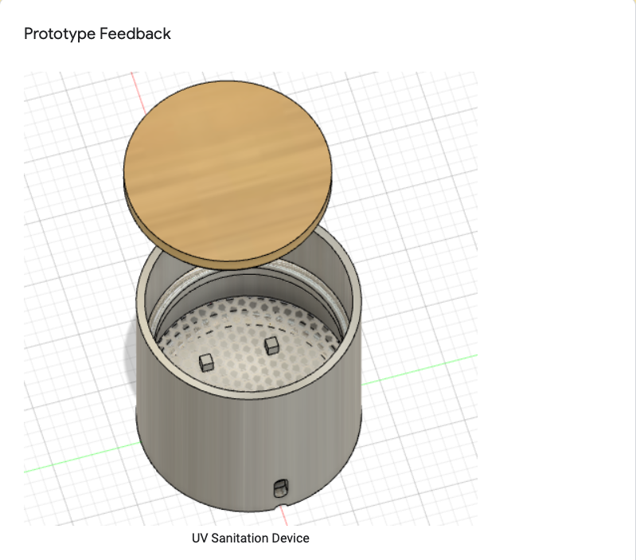
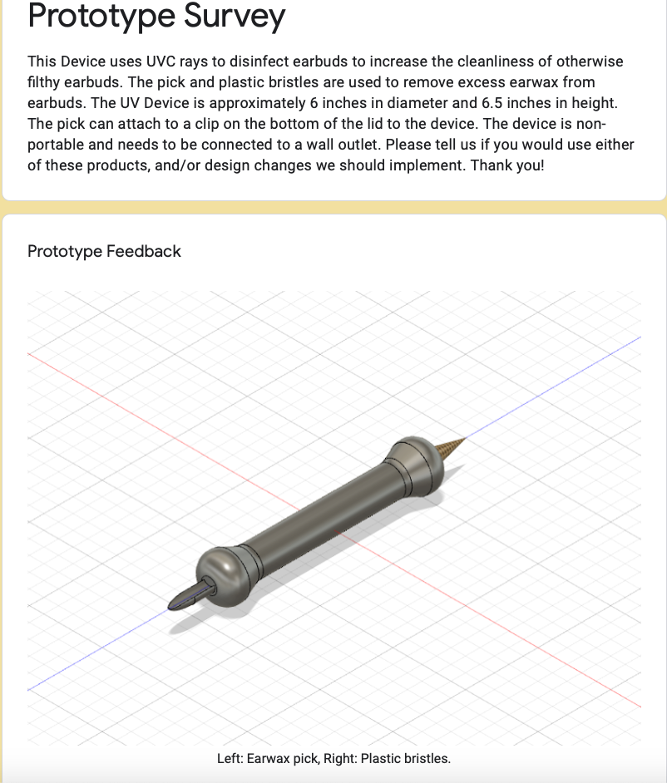
Although there seemed to be a lot of misinterpretation of our device in our survey results, we did receive some helpful feedback. The main design change we could make is to make our UVC device smaller. We realize now that a 6inch diameter is way too big for a pair of earbuds. If we had even more time and money, it would be amazing to somehow make our device even more compact and also portable. It is a little bit of a con that our device cannot be transported.

Figure 12: UV-C Box Design used in survey Figure 13: Earwax pick design used in survey

Element J
Due to the way we formatted our questions, we cannot create a graphical representation of our responses.

Element K
When we have been able to coordinate amongst ourselves we worked really well together. Our device, although flawed, is a great conceptual design. Had we had the resources/opportunity to actually build and test our design, we believe we could have improved it greatly and worked out all the kinks. Perhaps we will have this opportunity in the future, although it is doubtful. We had a great time working together, and couldn’t have gotten along better.

Citations
- Whittier Hospital Medical Center. “Are Earbuds Bad for My Ears?” Whittier Hospital Medical Center, 30 Sept. 2016, www.whittierhospital.com/WHMC-Blog/2016/September/Are-Earbuds-Bad-for-My-Ears-.aspx.
- Ansari, Hossein, and Asghar Mohammadpoorasl. “Using Earphone and Its Complications: An Increasing Pattern in Adolescents and Young Adults.” Health Scape, 5 Feb. 2016, pdfs.semanticscholar.org/67ad/10f81e3463bf86218f502fedfc0ebc40f257.pdf?_ga=2.106526913.331996947.1579291788-2009051738.1579291788.
- Alva, Richard. “Why Prolonged Earphone Use Can Damage Your Ears.” Ear Hero, 19 Nov. 2013, earhero.com/2013/11/19/why-prolonged-earphone-use-can-damage-your-ears/.
- Mazlan, et al. “EAR INFECTION AND HEARING LOSS AMONGST HEADPHONE USERS.” Malaysian Journal of Medical Sciences, July 2002, journal.usm.my/journal/MJMS-9-2-017.pdf.
- Sun, The. “Wearing Earbuds Regularly Could Cause Ear Infections, Health Professionals Warn.” New York Post, New York Post, 17 Oct. 2019, nypost.com/2019/10/17/wearing-earbuds-regularly-could-cause-ear-infections-health-professionals-warn/.
- Rivard, Abbie. “Earbuds: Not Your Ears' Best Buds after All.” Earbuds: Not Your Ear's Best Bud After All | Allina Health, 25 July 2018, www.allinahealth.org/healthysetgo/move/earbuds-not-your-ears-best-buds-after-all?id=36507247661.

